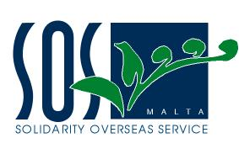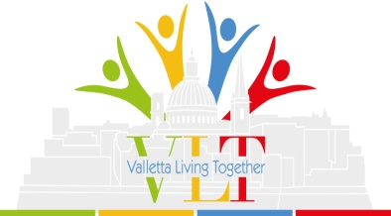
SOS Malta - Press Release – 08/07/2014
Valletta Realising the Diversity Advantage
On Monday 7th July SOS Malta launched Valletta Living Together (VLT): a 16 month project co-financed by the European Fund for Integration of Third Country Nationals which aims to actively improve the integration of migrants into Maltese society.
The Valletta Living Together Project (VLT) seeks to achieve the Council of Europe Intercultural City Status for Valletta, as a means to improving and celebrating the efforts of Valletta Local Council towards integrating people from other countries into the city. As part of this project, SOS Malta is collaborating with Valletta Local Council and the V18 Foundation to develop an intercultural cities strategy for Valletta.
The Intercultural Cities programme was launched in 2008 and so far, over 60 cities worldwide have signed up to undertake the programme. Cities can benefit greatly from the entrepreneurship, skills and creativity associated with cultural diversity provided that such policies are managed in a positive and competent way. The intercultural cities programme helps cities analyse and improve their policies and practices to enable them to manage diversity positively and for the benefit of the citizens of their city.
The kick-off stakeholder workshop was held at Dar l-Ewropa in Valletta on Monday bringing together Valletta local residents, third country nationals, council members, representatives of Ministries, NGOs and others who were invited to get involved and put forward their own ideas and initiatives to help create a Valletta specific Intercultural City strategy. Participants heard from Mayor Alexiei Dingli and from Neville Borg of the V18 Foundation, as well as hearing more about the project from SOS Malta. Through the workshop, a comprehensive overview of Valletta’s strengths and weaknesses in dealing with integration issues was reached. A number of keys areas for improvement, like that of enhanced communication between different groups living in Valletta, were highlighted.
The next step for the project will be an International Expert Meeting held on the 7th/8th of October this year. Council of Europe experts will meet with both local residents and city officials to make an in depth diagnosis of the cities’ achievements and needs in relation to good governance and intercultural policies. The desired outcome will be recommendations of a strategy for Valletta to become an Intercultural City and be among a group of respected and recognised intercultural cities worldwide.
For more information on the project, please contact: lorna.muscat@sosmalta.org
